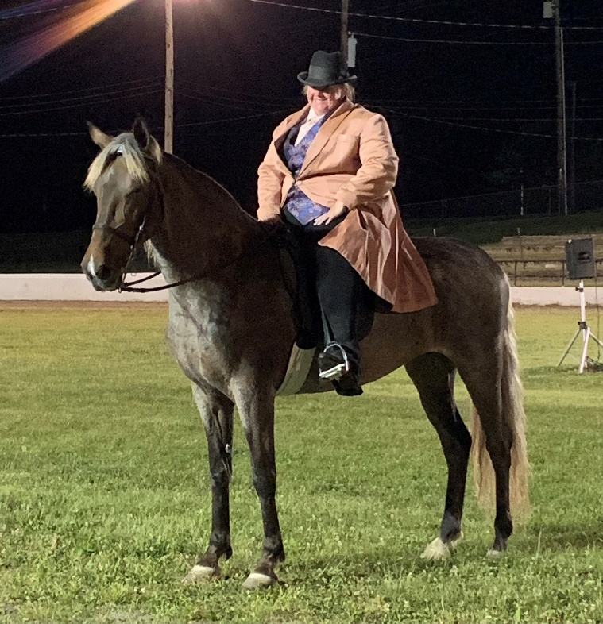

WOF Glamour & Style 2022
Trained and owned by Mary Kelley Tucker

Sharon Copher Memorial Open Trail Pleasure - 1st - MK
RMHA Sharon Copher Memorial Trail Championship - 1st - MK
Bluegrass Showcase Open Ladies Trail - 1st - MK
RMHA Bluegrass Showcase Novice Trail - 2nd - Leah
RMHA Lee County Saddle Club Summer Celebration Novice Trail - 1st - Leah
RMHA Lee County Saddle Club Summer Celebration Amateur Trail - 5th - Leah
RMHA Get Your Pink On Novice Trail - 1st - Leah Palmquist
RMHA Get Your Pink On Amateur Trail - 5th - Julie T.
Get Your Pink On Open Trail Pleasure - 3rd - MK
Get Your Pink On Open Pleasure Championship - 1st - Mary Kelley
RMHA Tollesboro Lions Club M/G Trail - 2nd - Leah
RMHA Tollesboro Lions Club Open Trail Pleasure - 2nd - Leah
RMHA Tollesboro Lions Club Amateur Trail Pleasure - 1st - Julie T
Gaited Horse Gala Open Trail Pleasure - 2nd
RMHA Gaited Horse Gala Open Trail Pleas. - 1st
RMHA Gaited Horse Gala Amateur Trail - 4th - Julie T.
RMHA I White Pine Amateur Trail Pleas. - 5th - Julie T.
RMHA II White Pine Ladies Trail - 2nd - MK
RMHA II White Pine Trail Pleasure Championship - 2nd - MK
WOF’s Glamour & Style
RMHA International Novice Trail - 3rd - Leah
RMHA High Point Ladies Trail Pleasure - 3rd - Mary Kelley

