Champions 2016

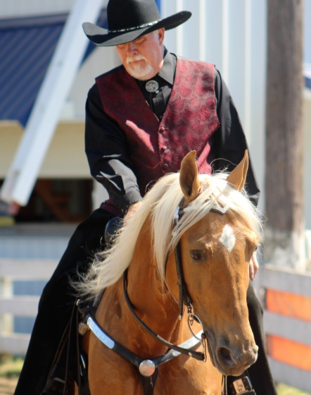
Moonlite Golden Nugget
- RMH Spring Show Case F Western - 2nd
- RMH Spring Show Case F Amateur CTP - 5th - Janet
- RMH Spring Show Case F CTP Stallions - 1st
- RMH Spring Classic S Western - 2nd
- RMH Spring Classic S Amateur CTP - 1st - Janet
- RMH Spring Classic S Novice CTP - 1st
- RMH Spring Classic S CTP Stallions - 1st
- RMH Spring Classic S CTP Championship - 3rd
- KMSHA Summer Kickoff - F - Novice Country Trail - Janet
- KMSHA Summer Kickoff - F5 & Older Stallions Country Trail - 1st
- KMSHA Summer Kickoff - S - Trail Obstacle - 2nd
- KMSHA Summer Kickoff - S - Open Western - 3rd
- KMSHA Summer Kickoff - S - Country Trail Championship - 3rd
- KMSHA Summer Kickoff - S - Amateur (Novice/AOT) Country Trail Champ. - 1st - Janet
- RMHA International - 5-9 YO Stallion Conf. - 3rd
- RMHA International - 4-9 YO Stallions CTP - 2nd
- RMHA International - 6-9 YO Amateur CTP - 5th - Janet
- RMHA International - Pole Bending - 2nd
- RMHA International - Stallions CTP - 3rd
- RMHA International - Adult Bareback - 1st - Andrea Crawford
- RMHA International - Amateur CTP Grand Ch - 4th
- RMHA International - 6+ YO Western - 3rd
- RMHA International - Western Pleas. Grand Ch. - 3rd
- RMHA International - CTP Grand Champ. - 5th

^{page]}

RRF Gold Nugget
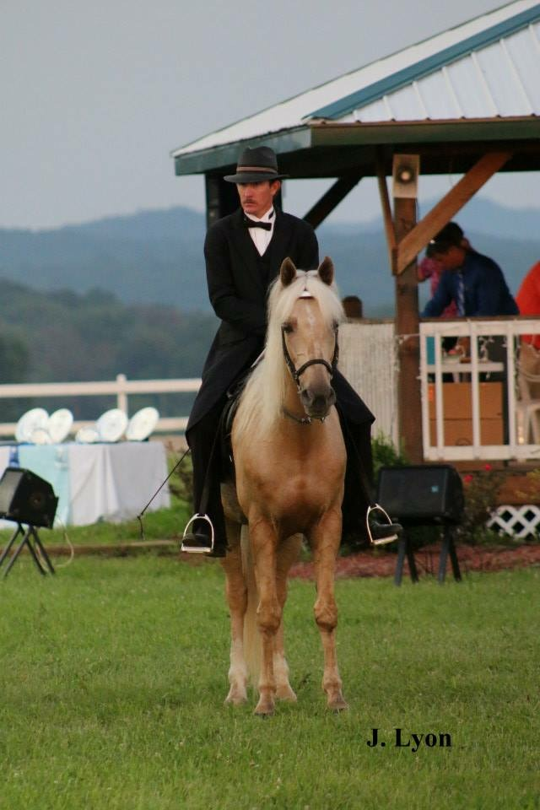
2009 Sam Tuttle Memorial Award winner RRF Gold Nugget is a beautiful sooty palomino. His excellent versatility skills allow him to be competitive in Conformation, Trail Obstacle, Open Driving, Pro-Am, ACTHA competitive trail and in on-the-rail classes. His owner, Steve Heuslein, shows him in the Open Amateur Classic Division and his wife, Susan, shows him in the Novice classes as well. He is being trained by Charlie DeAtley. Look for this beautiful palomino in the show ring again this year. He is truly a joy to watch.
- RMHA Summer Classic - Amateur Trail - 4th - Susan
- RMHA Summer Classic - Trail M/G - 1st
- RMH Spring Show Case F Trail M/G - 2nd
- RMH Spring Show Case F Men’s Trail - 3rd
- RMH Spring Show Case F Trail Champ. - 3rd
- RMH Spring Classic S Trail M/G - 3rd
- RMH Spring Classic S Men’s Trail - 4th
- RMH Spring Classic S Amateur Trail - 3rd - Susan
- KMSHA Summer Kickoff - F - Novice Trail - 5th - Susan
- KMSHA Summer Kickoff - F - 5 & over Mare/Gelding Trail - 4th
- KMSHA Summer Kickoff - S - Trail Obstacle - 3rd
- KMSHA Summer Kickoff - S - 5 & Over Mare/Gelding Trail - 1st
- RMHA International - 10+ M/G Conformation - 1st
- RMHA International - 5+ Conformation Champ. - 2nd
- RMHA International - 3+ Conformation Gr. Champ. - 3rd
- RMHA International - Pole Bending - 1st
- RMHA International - 6+ Open Western - 3rd
- RMHA International - 10+ M/G Trail - 2nd
- RMHA International - Adult Water Glass - 4th
- RMHA International - Adult Bareback - 2nd
- RMHA International - Rea Swan Versatility Award
- RMHA International - Sam Tuttle Memorial Award

[top of page]
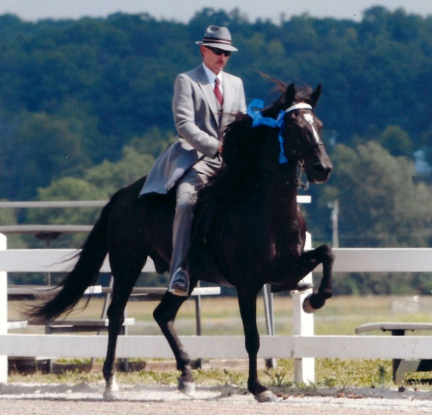
HBF Furious Revenge
Style baby style is what you’ll see with seven year old HBF Furious Revenge who is better known as “Duncan” around the barn. He has conformation that allows him to move well under saddle and really get your attention in the show ring. He will show in versatility and Park classes this year. Duncan is also great on competitive trail rides. You won’t want to miss this fella’s exciting performances. Duncan is owned by Don and Nancy Copland of Brookville, IN and is being trained by Charlie DeAtley.
- KMSHA Spring Premier - Friday and Saturday - 5+ M/G Park - 1st
- KMSHA Spring Premier - Park Championship - 2nd
- KMSHA Spring Premier - Trail Obstacle - 2nd
- RMHA Get Your Pink On - Show Pleasure M/G - 3rd
- KMSHA International - Adult Trail Obstacle - 2nd
- KMSHA International - 5+ M/G Park Pleas. - 3rd
- KMSHA International - 5+ Park Champ. - 2nd
- KMSHA International - Park Grand Champ. - 5th
- KMSHA Summer Kickoff - F - 5 & over Mare/Gelding Park - 2nd
- KMSHA Summer Kickoff - S - Adult Trail Obstacle - 4th
- KMSHA Summer Kickoff - S - 5 & Over Mare/Gelding Park - 1st
- KMSHA Summer Kickoff - S - Park Championship - 3rd
- RMH Spring Classic S Show Pleas. M/G - 1st
- RMH Spring Classic S Show Pleas. Champ - 2nd
- RMHA International - 5-9 YO M/G Conf - 4th
- RMHA International - 6-9 YO M/G Show Pleas. - 3rd
- RMHA International - Adult Trail Obstacle - 5th

^{[top of page]}
Barb's Stormy Knight
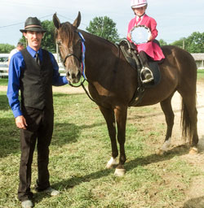
Barb’s Stormy Knight continues to wear many hats as far as his equine jobs go. Even though he’s in the AGMH Hall of Fame and has been the winner of numerous World Grand Championships including the Western World Grand Championships in all three Mountain Horse associations, he continues to be busy this year giving lessons and introducing the novice and juvenile rider to the show ring. He gave Ella and Drew, Don and Nancy’s grand children their first ride. Stormy is also a two time American Competitive Trail Horse (ACTHA) RMHA High Point winner and maintains that competitive spirit. Everyone loves Stormy. He’s owned by Don and Nancy Copland of Brookville, IN.
- KMSHA Spring Premier - 11 & Under CTP - 2nd - Ruby
- KMSHA Spring Premier - 12-17 CTP 4th /3rd - Lily
- KMSHA Spring Premier - Youth Trail Obstacle - 1st - Lily
- KMSHA Spring Premier - Youth Western - 3rd - Lily
- KMSHA Spring Premier - Showmanship - 2nd - Lily
- KMSHA Spring Premier - 12-17 CTP - 3rd - Lily
- KMSHA Spring Premier - 11 & Under CTP Champ - 3rd - Ruby
- KMSHA Spring Premier - 12-17 CTP Champ - 4th - Lily
- RMHA Get Your Pink On - 11 & Under Country Trail - 3rd - Ruby
- RMHA Get Your Pink On - Pink Class (Youth) - 3rd - Ruby KMSHA International - 5+ M/G Trail - 4th
- KMSHA Summer Kickoff - F - Juvenile 11 & Under Trail - 1st - Ruby
- KMSHA Summer Kickoff - F - Juvenile 11 & Under Country Trail - 2nd
- KMSHA Summer Kickoff - F - Youth 12-17 Country Trail - 4th - Chapel
- KMSHA Summer Kickoff - F - Youth 12-17 Trail - 5th - Chapel
- KMSHA Summer Kickoff - S - Youth Trail Obstacle - 1st - Chapel
- KMSHA Summer Kickoff - S - Juvenile 11 & Under Country Trail - 3rd - Ruby
- KMSHA Summer Kickoff - S - Youth 12-17 Trail – 4th - Chapel
- KMSHA International - Juvenile Trail Obstacle - 1st - Ruby
- KMSHA International - Juvenile Western - 2nd - Ruby
- KMSHA International - 11 & Under Trail - 3rd - Ruby
- KMSHA International - You & Me Trail - 3rd - Charlie/Ruby
- KMSHA International - Juvenile 11 & Under Trail Champ. - 3rd
- KMSHA International - Carson Masters Versatility Award
- RMH Spring Show Case F 12-17 CTP - 2nd - Lily
- RMH Spring Show Case F 12-17 Western - 4th - Lily
- RMH Spring Classic S 11 & U. West. - 1st - Ruby
- RMH Spring Classic S 12-17 CTP - 3rd - Lily
- RMH Spring Classic S 12-17 Western - 3rd - Lily
- RMH Spring Classic S 11 & U Trail - 1st Ruby
- RMH Spring Classic S Youth Trail Ch. - 4th Ruby
- RMHA International - 11 & Under Western - 3rd - Ruby
- RMHA International - 11 & Under Trail - 3rd - Ruby
- RMHA International - 11 & Under Trail Gr. Ch. - 3rd - Ruby
- RMHA International - Youth Pink Class - 3rd

^{[top of page]}

My Sweet Sydney
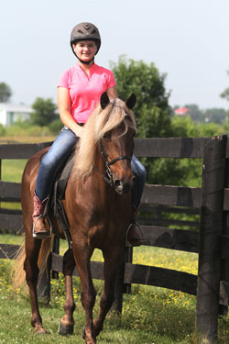
Sydney is continuing her show career in 2015. She is a lovely mare with a consistent gait and beautiful carriage. She will be strutting her stuff in professional, amateur, and novice classes this year in a combination of rail and versatility classes. Dillon Gray is her trainer here at Stoner Ridge Farm. She is owned by Steve and Susan Heuselin Heuslein of LaCrescent, MN.
- RMHA Summer Classic - Amateur CTP - 4th Susan
- RMHA Summer Classic - CTP M/G - 4th
- RMH Spring Show Case F CTP M/G - 2nd - Steve
- RMH Spring Show Case F Amateur CTP - 4th - Susan
- RMH Spring Classic S CTP M/G - 5th - Mary K.
- RMH Spring Classic S Amateur CTP - 5th - Susan
- KMSHA Summer Kickoff - F - Amateur Country Trail - 4th - Susan
- KMSHA Summer Kickoff - F - Trail Obstacle - 5th
- KMSHA Summer Kickoff - S - Amateur Country Trail - 4th - Susan
- KMSHA Summer Kickoff - S - 5 & Over Mare/Gelding Country Trail - 2nd
- KMSHA Summer Kickoff - S - Country Trail Championship - 4th - SteveRMHA International - 10+ M/G Conf. - 2nd
- RMHA International - 5+ Conf Champ - 5th
- RMHA International - Adult Trail Obstacle - 3rd
- RMHA International - Men’s Country Trail - 1st - Steve
- RMHA International - Ladies CTP - 5th

SRF’s Silver Sundown
- RMHA International - 10+ Master Stallion Conf. - 3rd
- RMHA International - 10+ Master Stallions Trail - 4th

Friskie River
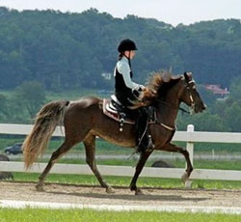
What a talented mare! Friskie River has energy to spare and loves to move. She is spectacular. Chapel and Friskie are planning to work in versatility events. Charlie, her trainer, will also be showing her in classes this year. You won’t want to miss their exciting performance. Friskie is owned by The Tinius family with Chapel as her primary rider.
- RMHA Get Your Pink On - Pink Class (Youth) - 1st - Chapel
- Water Glass – 3rd

Moriah Mae
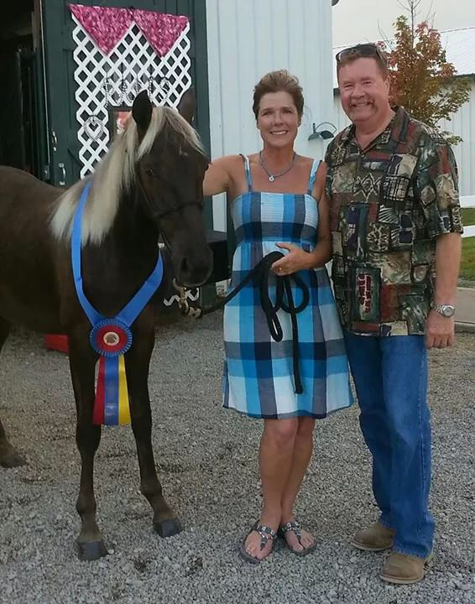
Moriah Mae will be returning to the show ring in 2016. She was the UMH Yearling Championship winner and the RMH International 2 Year Old and Under Conformation Championship Conformation winner in 2014. She is by SRF’s Silver Sundown and out of Sundown Special (a Tobe grand daughter). She is one you will want to watch! Moriah is owned by Steve and Susan Heuslein and trained by Charlie DeAtley.
- KMSHA Spring Premier - 3 yo CTP - 2nd
- KMSHA Spring Premier - Open Western - 3rd
- RMHA Summer Classic - 3 YO CTP - 1st
- KMSHA International - 3 YO CTP - 1st
- KMSHA International - 3 YO CTP Champ. 2nd
- KMSHA International - Adult Western Pleas. - 1st
- KMSHA International - CTP Grand Championship - 5th
- KMSHA International - Trail Obstacle - 5th
- RMH Spring Show Case F 3 & 4 yo Conf - 4th
- RMH Spring Show Case F Western - 1st
- RMH Spring Show Case F CTP M/G - 3rd
- RMH Spring Classic S 3 & 4 yo Conf - 1st
- KMSHA Summer Kickoff - F - 3 YO Open Country Trail - 3rd
- KMSHA Summer Kickoff - S - Open Western - 1st
- KMSHA Summer Kickoff - S - 3 yo Open Country Trail - 1st
- KMSHA Summer Kickoff - S - Country Trail Championship - 1st
- RMH Spring Classic S Western - 2nd
- RMH Spring Classic S CTP M/G - 3rd
- RMHA International - 3-4 YO M/G Conf. 3rd
- RMHA International - 3 YO CTP - 1st
- RMHA International - 3-5 YO Amateur CTP - 4th - Susan
- RMHA International - 3-5 YO Western - 1st
- RMHA International - Western Pleas. Grand Ch. - 2^{nd[}
Gaitway’s Jasmine Joy
- RMH Spring Show Case F CTP M/G - 5th
- RMH Spring Show Case F Amateur CTP - 1st - Steve
- RMH Spring Show Case F CTP Champ - 2nd - Charlie
- RMH Spring Classic S CTP M/G - 4th
- RMH Spring Classic S Amateur CTP - 4th - Steve
- KMSHA Summer Kickoff - F - Juvenile 11 & Under - 3rd - Carollynn
- KMSHA Summer Kickoff - F - Youth 12 – 17 Country Trail - 5th - Rachel
- KMSHA Summer Kickoff - F - 5 & Older Mare/Gelding Country Trail - 5th - Charlie
- KMSHA Summer Kickoff - S - Trail Obstacle - 1st
- KMSHA Summer Kickoff - S - Youth Western - 2nd - Carollynn
- KMSHA Summer Kickoff - S - Youth 11 & Under Country Trail - 2nd - Carollynn
- KMSHA Summer Kickoff - S - Youth 12-17 Country Trail - Rachel
- KMSHA Summer Kickoff - S - Amateur Country Trail Pleasure - 3rd - Steve
- RMHA International - 10+ M/G Conf. - 4th
- RMHA International - 11 & Under Western - 4th - Carollynn
- RMHA International - 11 & Under CTP - 3rd
- RMHA International - 11 & Under Equitation - 1st
- RMHA International - 11 & Under Showmanship - 1st
- RMHA International - 11 & Under CTP Gr. Champ. - 3rd

Sundown Sedona
Sundown Sedona will be making her show ring debut in 2016 under the direction of her trainer and handler, Charlie DeAtley. She is by SRF’s Silver Sundown out of My Sweet Sydney. We are looking forward to seeing what this talented filly can do. She has a lot of talent and a calm demeanor like her sire. There’s no telling what she’ll get up to this year. Sedona is owned by Steve and Susan Heuslein from LaCrescent, MN.
- KMSHA Spring Premier - Friday - 3 yo Trail - 4th
- KMSHA Spring Premier - Saturday - 3 yo Trail - 5th
- RMHA Summer Classic - 3 YO Trail - 1st
- KMSHA Summer Kickoff - F - 3 yo Open Trail - 3rd
- KMSHA Summer Kickoff - S - 3 yo Open Trail - 4th
- KMSHA International - 3 YO Trail - 4th
- KMSHA International - 3-4 YO Conf. - 4th
- KMSHA International - 3 YO Trail Champ. - 4th
- KMSHA International - Trail Obstacle - 3rd
- RMH Spring Show Case F 3 & 4 yo Conf - 3rd
- RMH Spring Show Case F 3 & 4 yo Trail - 4th
- RMH Spring Classic S 3 & 4 yo conf - 3rd
- RMHA International - 3-4 YO M/G Conf. 4th
- RMHA International - 3 YO Trail - 1st
- RMHA International - Pole Bending - 3rd

Pepper’s Just Plain Pretty

- RMH Spring Show Case F 12-17 CTP - 3rd - Carrie
- RMH Spring Show Case F 12-17 Western - 5th - Carrie
- RMH Spring Classic S 12-17 CTP - 4th - Carrie
- RMH Spring Classic S 12-17 West. - 2nd - Carrie
- RMH Spring Classic S Youth CTP Champ - 3rd
- RMHA International - Youth Trail Obstacle - 1st

Tango’s Dance Master

- KMSHA Spring Premier - 4 YO Trail - 3rd - Robert
- KMSHA Spring Premier - 4 yo Trail - 5th - Charlie
- KMSHA Spring Premier - 12-17 CTP 4th /3rd - Lily
- KMSHA Spring Premier - Youth Trail Obstacle - 1st - Lily
- KMSHA Spring Premier - Youth Western - 3rd - Lily
- KMSHA Spring Premier - Showmanship - 2nd - Lily
- KMSHA Spring Premier - 12-17 CTP - 3rd - Lily
- KMSHA Spring Premier - 12-17 CTP Champ - 4th - Lily
- RMH Spring Show Case F Western - 2nd
- RMH Spring Show Case F CTP Stallions - 1st
- RMH Spring Classic S Western - 2nd
- RMH Spring Classic S CTP Championship - 3rd
- Spring Classic S 12-17 Trail - 3rd - Lily
- RMHA International - 12-17 Youth Trail - 3rd

AMATEUR RIDERS
Susan Heuslein
- RMH Spring Show Case - MY Sweet Sydney - Amateur CTP - 4th
- RMHA Spring Classic - My Sweet Sydney - Amateur CTP - 5th
- RMHA Spring Classic - RRF Gold Nugget - Amateur Trail - 3rd
- KMSHA Summer Kickoff - F - RRF Gold Nugget - Novice Trail - 5th - Susan
- KMSHA Summer Kickoff - F - My Sweet Sydney - Amateur Country Trail - 4th
- KMSHA Summer Kickoff - S - My Sweet Sydney - Amateur Country Trail - 4th

Steve Heuslein
- RMH Spring Show Case - My Sweet Sydney - CTP M/G - 2nd - Steve
- RMH Spring Show Case - Gaitway’s Jasmine Joy - Amateur CTP - 1st
- RMHA Spring Classic - Gaitway’s Jasmine Joy - Amateur CTP - 4th
- KMSHA Summer Kickoff - S - Gaitway’s Jasmine Joy - Amateur Country Trail Pleasure - 3rd
- KMSHA Summer Kickoff - S - My Sweet Sydney - Country Trail Championship - 4th
^{[top of page]}

Janet Berkin
- RMH Spring Show Case - Moonlite Golden Nugget - Amateur CTP - 5th - Janet
- RMHA Spring Classic - Moonlite Golden Nugget - Amateur CTP - 1st - Janet
- RMHA Spring Classic - Moonlite Golden Nugget - Novice CTP - 1st
- KMSHA Summer Kickoff - F - Moonlite Golden Nugget - Novice Country Trail - 1st
- KMSHA Summer Kickoff - S - Moonlite Golden Nugget - Amateur (Novice/AOT) Country Trail Champ. - 1st
^{[top of page]}

YOUTH RIDERS

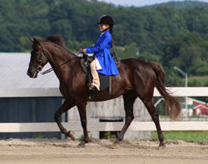
Carollynn Tucker
- KMSHA Summer Kickoff - F - Gaitway’s Jasmine Joy - Juvenile 11 & Under - 3rd
- KMSHA Summer Kickoff - S - Gaitway’s Jasmine Joy - Youth Western - 2nd
- KMSHA Summer Kickoff - S - Gaitway’s Jasmine Joyu - Youth 11 & Under Country Trail - 2nd
- RMHA Get Your Pink On - Gaitway’s Jasmine Joy - Youth 11 & Under Country Trail - 1st
^{[top of page]}
Ruby DeAtley
- KMSHA Spring Premier - 11 & Under CTP - 2nd - Ruby
- KMSHA Spring Premier - 11 & Under CTP Champ - 3rd
- RMHA Spring Classic - Barb’s Stormy Knight - 11 & U. West. - 1st
- RMHA Spring Classic - Barb’s Stormy Knight - 11 & U Trail - 1st
- RMHA Spring Classic - Barb’s Stormy Knight - Youth Trail Ch. - 4th
- KMSHA Summer Kickoff - F - Barb’s Stormy Knight - Juvenile 11 & Under Trail - 1st
- KMSHA Summer Kickoff - F - Barb’s Stormy Knight - Juvenile 11 & Under Country Trail - 2nd
- KMSHA Summer Kickoff - S - Barb’s Stormy Knight - Juvenile 11 & Under Country Trail - 3rd
- RMHA Get Your Pink On - 11 & Under Country Trail - 3rd
- RMHA Get Your Pink On - Pink Class (Youth) - 3rd
- KMSHA Spring Premier - 11 & Under CTP - 2nd
- KMSHA Spring Premier - 11 & Under CTP Champ - 3rd
- RMH Spring Classic S 11 & U. West. - 1st - Ruby
- RMH Spring Classic S 11 & U Trail - 1st Ruby
- RMH Spring Classic S Youth Trail Ch. - 4th Ruby
- RMHA International - 11 & Under Western - 3rd - Ruby
Lily George
- KMSHA Spring Premier - Barb’s Stormy Knight - 12-17 CTP - 4th
- KMSHA Spring Premier - Barb’s Stormy Knight - 12-17 CTP - 3rd
- KMSHA Spring Premier - Barb’s Stormy Knight - Youth Trail Obstacle - 1st
- KMSHA Spring Premier - Barb’s Stormy Knight - Youth Western - 3rd
- KMSHA Spring Premier - Barb’s Stormy Knight - Showmanship - 2nd
- KMSHA Spring Premier - Barb’s Stormy Knight - 12-17 CTP - 3rd
- KMSHA Spring Premier - Barb’s Stormy Knight - 12-17 CTP Champ - 4th
- RMH Spring Show Case - Tango’s Dance Master - 12-17 Trail - 1st
- RMH Spring Show Case - Tango’s Dance Master - Youth Trail Champ - 4th
- RMHA Spring Classic - Tango’s Dance Master - 12-17 Trail - 3rd
- RMH Spring Show Case - Barb’s Stormy Knight - 12-17 CTP - 2nd
- RMH Spring Show Case - Barb’s Stormy Knight - 12-17 Western - 4th
- RMHA Spring Classic - Barb’s Stormy Knight - 12-17 CTP - 3rd
- RMHA Spring Classic - Barb’s Stormy Knight - 12-17 Western - 3rd
- RMHA International – Tango’s Dance Master - 12-17 Youth Trail - 3rd

Chapel Tinius
- KMSHA Summer Kickoff - F - Barb’s Stormy Knight - Youth 12-17 Country Trail - 4th
- KMSHA Summer Kickoff - F - Barb’s Stormy Knight - Youth 12-17 Trail - 5th
- KMSHA Summer Kickoff - S - Barb’s Stormy Knight - Youth Trail Obstacle - 1st
- KMSHA Summer Kickoff - S - Barb’s Stormy Knight - Youth 12-17 Trail – 4th
- RMHA Get Your Pink On - Friskie River - Pink Class (Youth) - 1st
- RMHA Get Your Pink On - Friskie River - Water Glass (Youth) - 2nd l
^{[top of page]}

Carrie Cockerham
- RMH Spring Show Case - Pepper’s Just Plain Pretty - 12-17 CTP - 3rd
- RMH Spring Show Case - Pepper’s Just Plain Pretty - 12-17 Western - 5th
- RMHA Spring Classic - Pepper’s Just Plain Pretty - 12-17 CTP - 4th
- RMHA Spring Classic - Pepper’s Just Plain Pretty - 12-17 Western - 2nd
- RMHA Spring Classic - Pepper’s Just Plain Pretty - Youth CTP Champ - 3rd
- RMHA International - Youth Trail Obstacle - 1st

Rachel Sharp
- KMSHA Summer Kickoff - F - Gaitway’s Jasmine Joy - Youth 12 – 17 Country Trail - 5th - Rachel
- KMSHA Summer Kickoff - S - Gaitway’s Jasmine Joy - Youth 12-17 Country Trail - Rachel
- RMHA Get Your Pink On - Gaitway’s Jasmine Joy - Youth 12-17 Country Trail - 2nd

